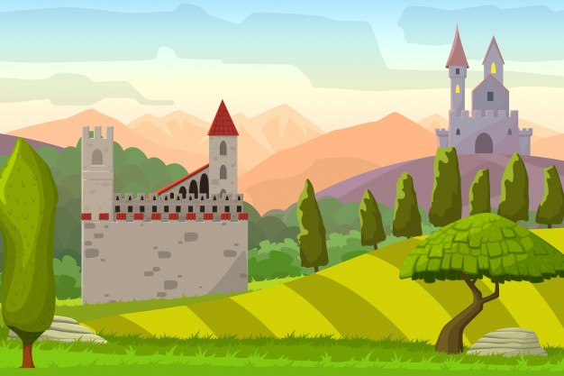

Eskevich, E. (2017) Castles on hills medieval landscapevector cartoon illustration, accessed 11 March 2018, <<https://www.freepik.com/free-vector/castles-on-hills-medieval-landscapevector-cartoon-illustration_1053598.htm>>



Fillerthefreak. (2017) Undertale Battle buttons, Accessed 11 March 2018, <https://www.spriters-resource.com/pc_computer/undertale/sheet/76661/>

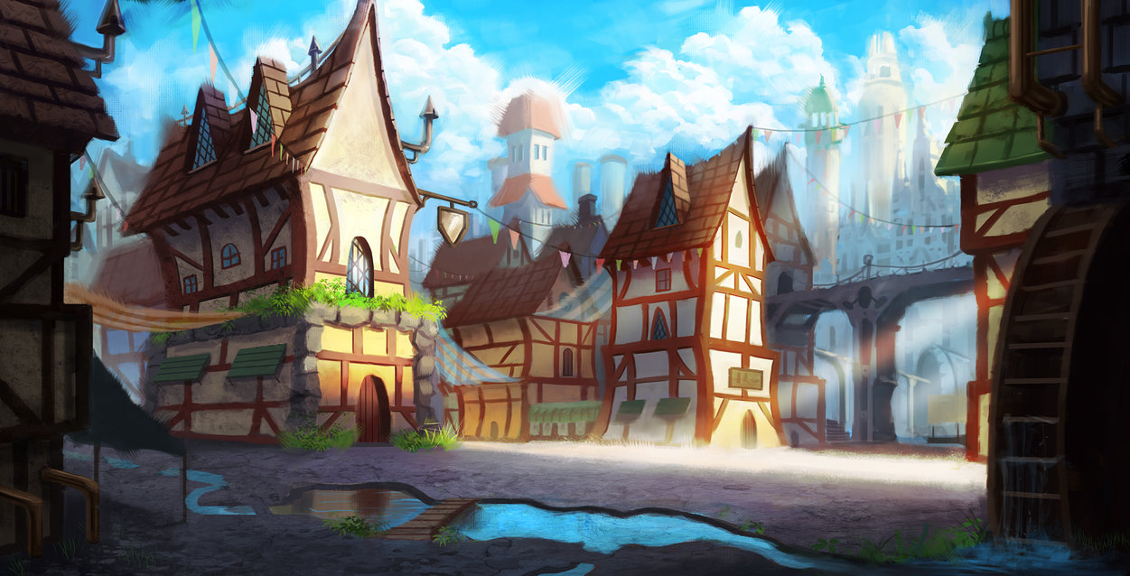

tommyscottart. (2011), Village, accessed 11 March 2018, <<https://tommyscottart.deviantart.com/art/Village-259887520>>

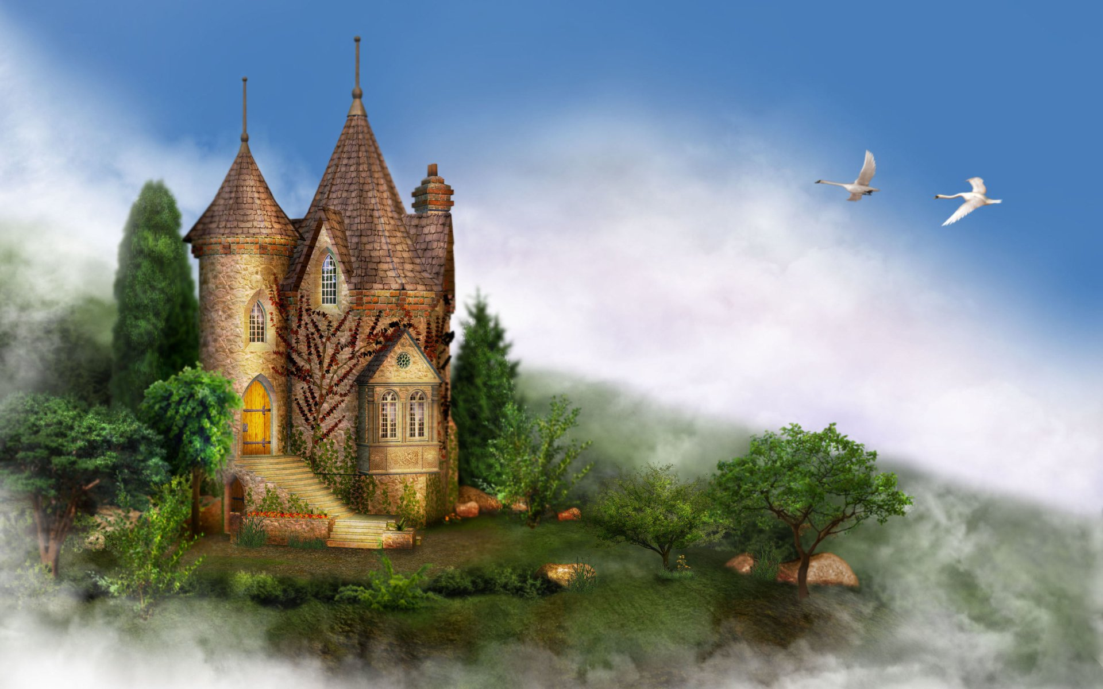

Darkness. (2012), Castle, Accessed 11 March 2018, <https://wall.alphacoders.com/big.php?i=211091>